Date of Submission: 10/07/2024

Name: Pranay Vunnam

Institute: SRM Institute of Science and Technology Kattankulathur

Branch/Specialisation: B-TECH AI

Register Number: RA2311047010082

Internal Mentor: Dr. Sumathy G.

External Mentor: Dr. Vasudha Kumari (AI Software Solutions Engineer, Intel)

**INTEL UNNATI PROJECT**

Problem statement:-

* **Intel Products Sentiment Analysis from Online Reviews**

**INTRODUCTION**

* From textual data ,the preprocessing of the data has been started . After that feature extraction and classification process has begun and finally led to prediction of the Sentimental Analysis.
* Generated the datasets by using a library called Synthetic data for Intel Processors like i3,i5,i7,i9.
* Analysis of Data-Successfully demonstrated sentimental analysis and was able to differentiate the data into positive or neutral or negative sentiment analysis.
* Data Cleaning- Data Cleaning has been done to check uppercase and lowercase characters and use of special characters like !,@ etc and scrapping of white spaces.
* Under Sentimental Analysis ,successfully differentiated the reviews into positive or neutral or neutral by usage of keywords.

**OBJECTIVES-**

* To scrap the reviews available on different sources in the last 3 - 5 years.
* Applying various exploratory data analysis, machine learning and natural programming techniques to find the sentiments of products, clustering of affinity reviews, trends of sentiments over period of time,
* Features and keywords extraction to specific sentiments, recommendation on key improvements based on users reviews for future products.
* Key Summary and Recommendations based on analysis and model outcomes.

**FLOWCHART**

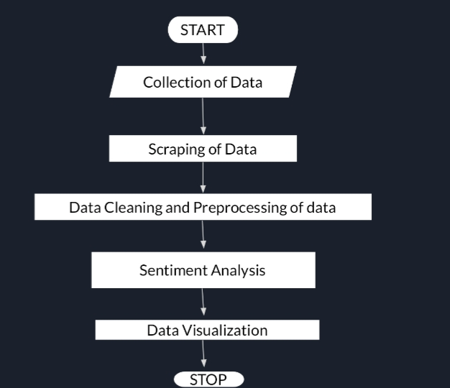

**HOW TO RUN:-**

* Run the code in a jupyter notebook for a good experience.
* Download the dataset file
* Save the file as **final_reviews.csv**

(I have uploaded the file in jupyter notebook and then I have done the project)

* The project output will display the pie chart which shows sentiment analysis.

**Code:**

<https://github.com/Pranay3284/INTEL-PROJECT/blob/main/intel2.ipynb>

**POWERPOINT PRESENTATION:**

<https://github.com/Pranay3284/INTEL-PROJECT/blob/main/INTEL%20UNNATI%20PROJECT-3.pptx>

**RESULT:**

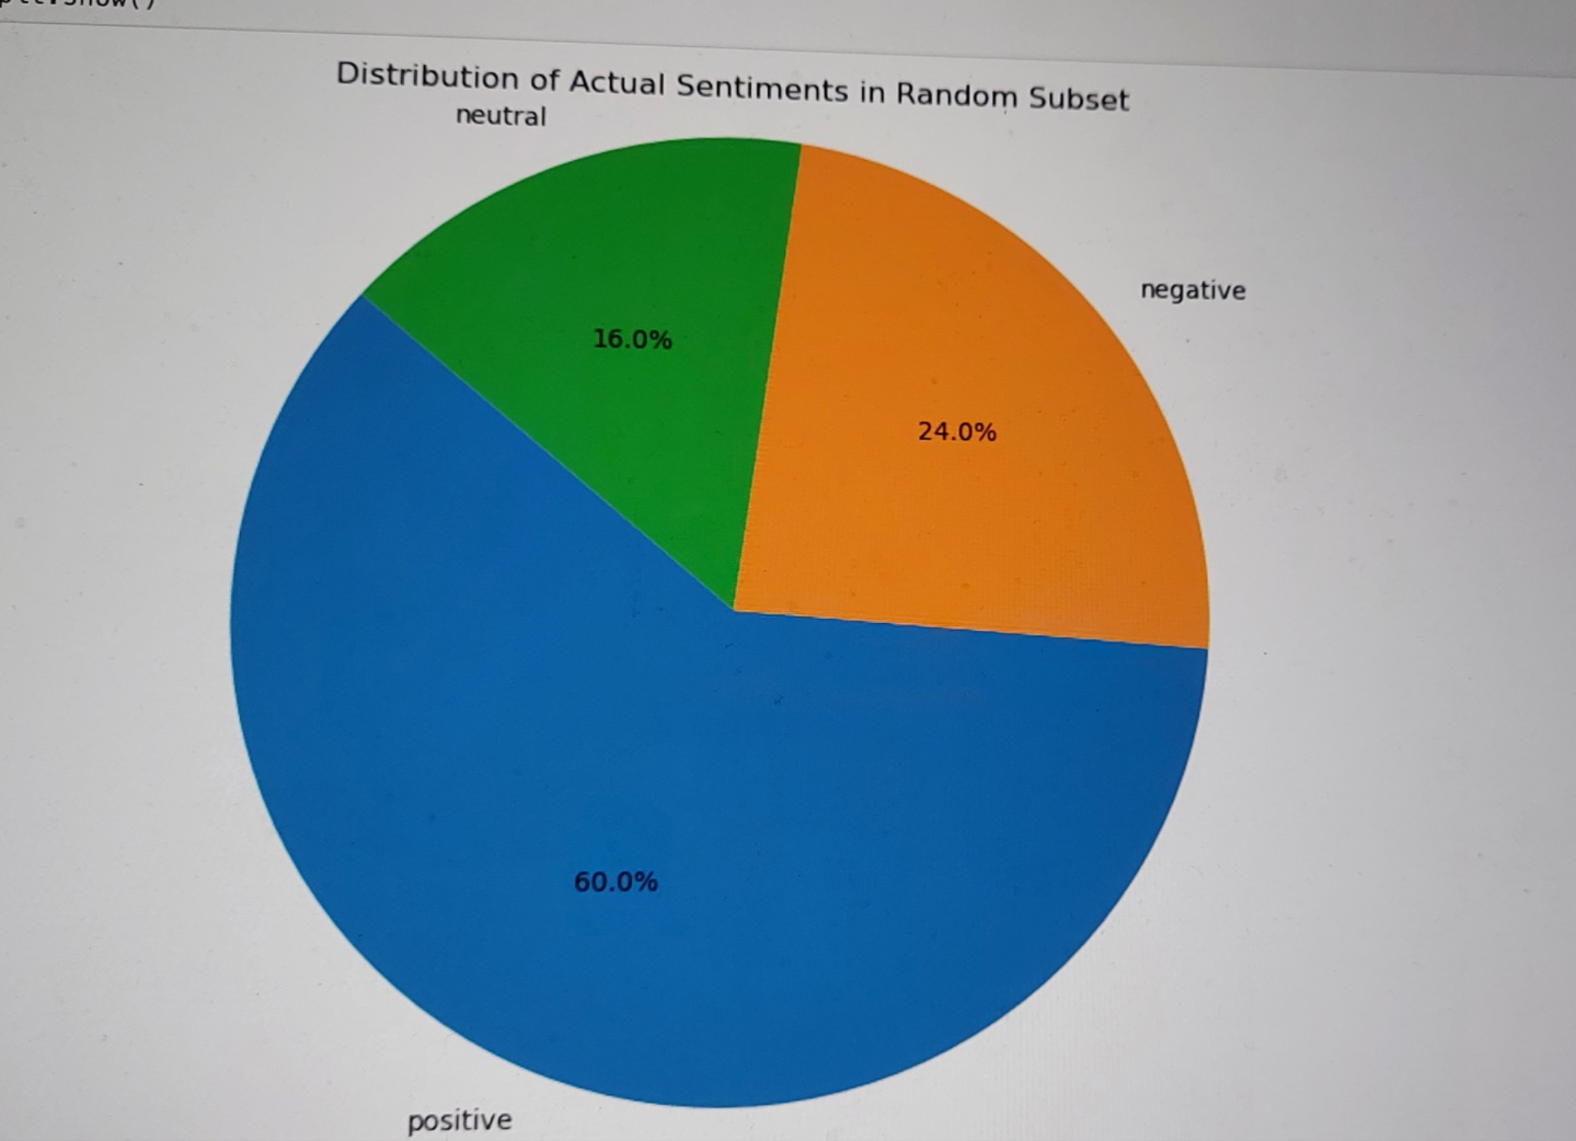

**CONCLUSION**

* This project inferred the web scraping of data and using Naive Bayes classifiers ,successfully demonstrated the Sentiment Analysis
* Identified trends and other insights in sentiment data
* Moreover,there was efficient extraction of data and used classification reports in sentiment analysis.
* Majority of the reviews were of positive sentiment analysis followed by negative sentiment analysis.
* Overall, participating in Intel's Industrial Training Program was
* an invaluable experience.
* It provided practical skills, industry,insights, and the opportunity to work on enhanced technology.